2.1 Functions & evolution of HRM - Question bank

1 . What is the management process for forecasting an organization’s current and future staff needs a part of?

A. Workforce planning
B. Work patterns and practices
C. Training
D. Recruitment

2. Companies are increasingly resorting to flexible work structures, such as teleworking, homeworking and portfolio working. Which of the following does not provide a reason for this trend?

A. Cost savings arising from fewer fringe benefits, less training expense for workers in these newstructures
B. The greater flexibility offered to businesses
C. Businesses are looking for dedicated employees who believe in employee loyalty and a ‘job for life’philosophy
D. Businesses are looking to reduce their core workers as more jobs get outsourced

3. Dismissal on account of a worker being forced into a resignation by making it difficult for the worker to continue inthe job is referred to as what?

A. Redeployment
B. Discrimination
C. Redundancy
D. Constructive dismissal

4 . Fill in the missing parts in the following text:

___________________________- The ability and willingness of employees to relocate to another location or country for work reasons.

5. Drag the text boxes to fill in the missing parts in the following text:

Dismissal on account of an employee not having appropriate and _______________necessary skills and would be classified as_________________________ dismissal based, on ________________________ systems and the requirements ofprofessional governing bodies. However, dismissal based on race, religion, age, ______________________, sexual preferences, or pregnancy would be deemed as ______________________ dismissal, and__________________ in most countries. ____________________________ dismissal occurs when a worker is pressurized into _____________________ by making it difficult for the worker to continue in the job. Essentially, they leave the job instead of being fired (___________________________________ ).

6. Which term describes the relocation of business operations back to their country of origin, after having originally moved overseas on account of cost reasons?

A. Relocating
B. Re-shoring
C. Outsourcing
D. Offshoring

7. Which of the following is not usually a reason for outsourcing?

A. Non-essential or non-core activities
B. Lack of skilled or specialist staff
C. Lower production costs
D. Falling demand for the product

8. Drag the text boxes to fill in the missing parts in the following text:
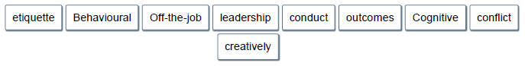

________________________training often requires employees to go off-site, i.e. training that is not on the work premises. ________________________training includes learning activities that improve memory, attention span, problem-solving skills as well as one’s ability to think ___________________and quickly._____________________ training seeks to change or improve the ___________________________________ or actions of employees to achieve desired _____________________. Team building, motivation training, ________________________ resolution training, anger management, stress management,___________________________ training, or business _________________________ training are various examples of behavioral training.

9. Fill in the missing parts in the following text:

____________________________________- Also known as a performance review, this is the formal procedure of assessing the performance and effectiveness of an employee, about his/her job description.

10 . Fill in the missing parts in the following text:

_____________________________________- This happens when an organization relocates some of its operations overseas, usually due to cost advantages.

11. Fill in the missing parts in the following text:

_________________________________________- The opposite of labor turnover, this measures the ability of an organization to keep its employees at the firm.

12 . Fill in the missing parts in the following text:

__________________________________________- A form of flexible work practice that enables employees to work a set number of core hours each week, often at the office during peak periods of the day and/or week.

13. Which of the following does not directly contribute to and aid in workforce planning?

A. Demographic trends in the population
B. Promotional strategies of the business
C. Labour turnover in recent years
D. State of the economy and unemployment rate in the industry

14 . Drag the text boxes to fill in the missing parts in the following text:
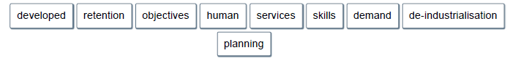

Workforce _________________________ involves analyzing and forecasting the_________________________________ number of workers and the of those workers needed by the organization to achieve its organizational __________________________. It involves the recruitment,_____________________________, redundancy, and performance management of ______________________________________ resources in the organization. For example,________________________________ in most ______________________________(high-income) countries has occurred as a result of manufacturing output moving to countries with cheaper labor.T his has led to the emergence of _________________________________and knowledge-based industries being the dominant parts of these economies, hence also driving the ________________________________for skilled labor in these sectors.

15 . Type in the key term from the definition below:

When a person’s employment is ended against the will of the employee, usually for breaching the terms aandconditionsin the employment contract. _________________________________

16 . Fill in the missing parts in the following text:

_____________________________________factors - The issues or features that are within the control of the organization, e.g.staff remuneration and approaches to training.

17. Which term describes a person having several different part-time jobs, all carried out simultaneously?

A. Homeworker
B. Core worker
C. Portfolio worker
D. Teleworker

18 . Which of the following is not an advantage of outsourcing?

A. Can lead to unethical business practices by outside service providers
B. Outsourced activities need specialists staff but contracts are awarded to the bidder offering the lowest costs
C. Improves worker flexibility
D. Outsourced activities need specialists staff but contracts are awarded to the bidder offering the lowest costs

19 . Fill in the missing parts in the following text:

_______________________________________- Occurs when an organization no longer has a job for the employer or when the employer can no longer afford to hire the employee, i.e. the job ceases to exist.

20 . Fill in the missing parts in the following text:

______________________________________- The opposite of offshoring, as it is the process of bringing back business operations, such as manufacturing, that were previously offshored.

21.

_________________________-degree appraisal refers to a type of appraisal system that provides ___________________ from a range of people who work with or _____________________ with the appraisee, such as their line manager, co-workers, subordinates and even ______________________________.

22.

__________________________ average age of the population is known as an _____________________.

23.

__________________________, also known as a performance review, is the formal procedure of _____________________ the performance and ______________________of an employee, about his/her job ______________________________.

24.

_______________________________ is a type of training that focuses on developing the ___________________ and intrapersonal skills of workers.

25.
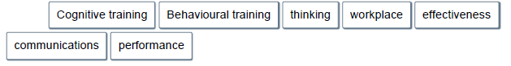

______________________________ is a method of training that focuses on improving an employee’s ________________ skills to improve their performance and ___________________________ in the ____________________________.

26.

_______________________is the study of population trends, such as gender and _______________________distributions within the population.

27:

____________________________takes place when an employer decides to terminate a worker’s ____________________ofemployment, usually due to the worker’s ________________________ and/or a breach of the terms and ______________________________of employment.

28.


_______________________________factors are the issues or _____________________________that are beyond the control of the organization, e.g. __________________________ wage legislation.

29.

______________________ refers to a form of flexible work practice that enables employees to work a _______________________number of core hours each week, often at the office during peak periods of the day and/or ____________________________.

30. 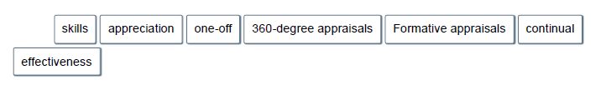

____________________________ are a type of appraisal that takes place on a _____________________ basis to allow workers to improve their performance and __________________________ at work.

31.

____________________________mobility means the ability and willingness of employees to relocate to another ____________________________ or country for work reasons.

32.
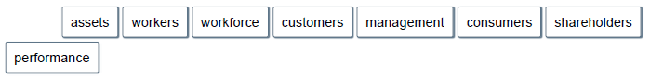

Human resource management (HRM) is a broad term used to describe the overall of _________________________ organization’s _______________________________, such as attracting, selecting, training, assessing, rewarding, and retaining ___________________________.

33.
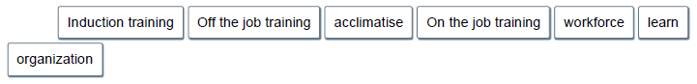

____________________________is a type of training intended for new employees to help them ____________________________withthe people, policies and proc, esses of the ___________________________.

34.

_______________________________ factors are the issues or features that are within the control of the organization, such as _______________________ and approaches to ____________________________.

35.
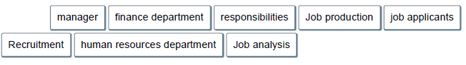

_________________________ refers to the process of examining what a particular job involves, thereby enabling the ___________________________ to determine the roles, tasks, duties, _________________________, and skills of a person required to do the job.

36.


A job _______________________ is a document containing the particulars of a job, such as the job title, roles and, _____________________________ and other professional duties.

37.

A job ______________________ is an appraisal of the value of a job about other jobs in the ___________________, so that the ___________________ and other rewards can be determined in an objective, ___________________________, and fair manner.

38.
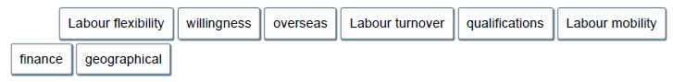

___________________________ refers to the measurement of the extent to which workers have the ability and ___________________________ to move between _______________________locations and/or occupations for their employment.

39.
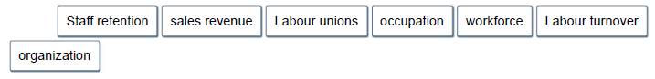

________________________________ refers to the number of people who leave an ________________________, expressed as a percentage of the _________________________________, per period (usually one year).

40.

______________________refers to the training process of pairing an employee (the trainee or mentee) with a more ____________________________colleague (the mentor) who acts as a coach, trainer or __________________________.

41.

________________________workers are people who move to other _________________________ in search of better job opportunities

42.
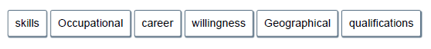

____________________mobility is the ability and _____________________of employees to do another job or to pursue adifferent _________________________.

43.


_______________________________ the job training is a type of training led by ___________________ specialists and takes place away from the place of work.

44.
_________________________happens when an organization _______________ some of its operations overseas, usuallydue to _______________________advantages.

45.


_____________________ the job training is a type of _______________________that takes place within the organization, employees are performing tasks _______________________- the place of work.

46.

____________________, also known as subcontracting, is the use of ___________________ (third-party) personnel forcertain non-core business _____________________________.

47.
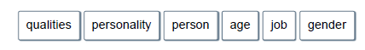
________________________specification refers to a document containing details of the attributes and _________________________ofthe ideal person for a particular job, such as preferred qualifications, experiences, knowledge, skills, and __________________________.

48.


A _______________________________ refers to the career ______________________ of an employee in terms of their ___________________________________ranking and professional responsibilities within the workplace.

49.


_____________________ is the process of hiring suitable workers. This would typically involve a thorough __________________________in order to attract ____________________ candidates and then to selecting
( _______________________________)the one(s) most suited to the job.

50.


The ____________________________ process is a major and vital aspect of human resource management, which refers to the _____________________________ involved in the hiring of the right employees, with the right ________________and attitudes.

51.


________________________ occurs when an organization no longer has a __________________________ for the employee or when the employee can no longer _____________________________to hire the employee, i.e. the job ceases to exist.

52.
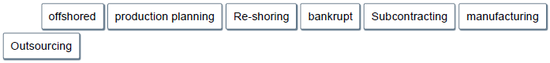

___________________________, the opposite of offshoring, is the process of bringing back business operations, such as ____________________________that was previously.

53.

_______________________is the opposite of _________________________, as it measures the ability of an organization to keep its _____________________________ at the firm over some time, usually a ________________.

54.
_______________________ is a type of appraisal system that involves the individual employee ______________on and rating his/her performance against pre-agreed ______________________________.

55.


______________________refers to the process of employers choosing the most ____________________applicants and invitingthem for a job ______________________________ .

56.
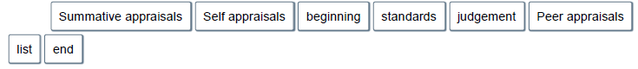
_______________________ are a type of appraisal conducted periodically or at the ________________________of a task or project, so includes an element of making a ______________________________about whether the appraisee has passed the agreed ___________________________.

57.
_____________________refers to a _________________________working practice that involves employees being away from the office as they rely on the use of telecommunications technologies, such as _______________________ and mobile technologies.

58.
______________________is the provision of ______________________education, and can be classified as either on-the-job oroff-the-job.

59.


Training refers to the _________________________ of ______________________________ and teaching (or mentoring) employees how to _____________________________ certain tasks in their job.
60.
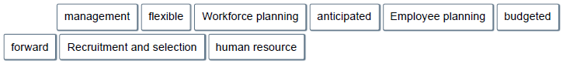

_________________________also known as _________________________ planning, refers to the ongoing process through which the current and future human resource needs of a business are identified and _______________________.

ANSWERS KEY :

- B ( Advancements in telecommunications, making the technology cheaper and faster, as well as rising office rents have hastened the spread of teleworking as an employment practice.)

- Induction

- Off the job

- B ( Unless specific fitness tests are required for a job, most jobs would use a mix of the other three listed generic tests: aptitude tests, psychometric tests, and intelligence tests. Many jobs may require a medical test, but this is not a form of testing the candidate’s ability to do the actual job. )

- A ( Also known as retrenchment or layoffs, redundancies occur when the employer can no longer afford or no longer has a need to keep the worker on the job. )

- C ( Although some labor turnover in any organization is inevitable as some employees leave for personal or professional reasons, a high labor turnover rate is often indicative of an unhappy workforce.)

- D ( Cognitive training includes learning activities that improve memory, attention span, prob problem-solving as well as one’s ability to think creatively and quickly.)

- Qualifications / fair/legal / gender / illegal / Constructive /resignation / dismissed

- Job analysis

- Person specification

- C / A portfolio worker is a person who has several different part-time jobs, all carried out simultaneously. Portfolio workers provide flexibility to a business and allow an employee to make use of his or her various skills to maximaximizenings whilst giving him/her the benefit of flexi-time employment.

- Flexitime

- Workforce planning

- C / Offshoring is the act of relocating business activities and processes overseas, due to cost advantages.

- A / Off-the-job training often requires employees to go off-site, i.e. not on the work premises.

- Offshoring

- Dismissal

- D / Labour turnover rate gives the percentage of total staff who leave every year. In this case, the rate is 20/200 × 100 = 10%.

- A / Internal recruitment involves hiring people from within the existing workforce to fill a new vacancy, so this could make it harder to get new ideas into a business.

- D / Dismissal based on race, religion, age, gender, sexual preferences, or pregnancy would be deemed as unfair dismissal.

- 360 / feedback/interact/customers

- Higher / aging population

- Appraisal / assessing / effectiveness/description

- Behavioural training / interpersonal

- Cognitive training / [thinking] / effectiveness/workplace

- Demography/age

- Dismissal/contract/incompetence/conditions

- External factors are the issues or factors that are beyond the control of the organization, e.g. minimum wage legislation.

- Flexitime refers to a form of flexible work practice that enables employees to work a set number of core hours each week, often at the office during peak periods of the day and/or week.

- Formative appraisals are a type of appraisal that take ptakescontinuallys to allow workers to improve their performance and effectiveness at work.

- Geographical mobility means the ability and willingness of employees to relocate to another location or country for work reasons.

- Human resource management (HRM) is a broad term used to describe the overall management of an organization's workforce, such as attracting, selecting, training, assessing, rewarding, and retaining workers

- Induction is a type of training intended for new employees to help them acclimatize to the people, policies, and processes of the organization.

- Internal factors are the issues or features that are within the control of the organization, such as staff remuneration and approaches to training.

- Job analysis refers to the process of examining what a particular job involves, thereby enabling the human resources department to determine the roles, tasks, duties, responsibilities, and skills of a person required to do the job.

- A job description is a document containing the particulars of a job, such as the job title, roles and responsibilities, and other professional duties.

- A job evaluation is an appraisal of the value of a job to other jobs in the organization so that the remuneration and other rewards can be determined in an objective, transparent, and fair manner.

- Labour mobility refers to the measurement of the extent to which workers have the ability and willingness to move between geographical locations and/or occupations for their employment.

- Labour turnover refers to the number of people who leave an organization, expressed as a percentage of the workforce, per period (usually one year).

- Mentoring refers to the training process of pairing an employee (the trainee or mentee) with a more experienced colleague (the mentor) who acts as a coach, trainer, or advisor.

- Migrant workers are people who move to other countries in search of better job opportunities.

- Occupational mobility is the ability and willingness of employees to do another job or to pursue a different career.

- Off-the-job training is a type of training led by external specialists and takes place away from the place of work.

- Offshoring happens when an organization relocates some of its operations overseas, usually due to cost advantages.

- On-the-job training is a type of training that takes place within the organization, so employees are performing tasks at the place of work.

- Outsourcing, also known as subcontracting, this is the use of external (third-party) personnel for certain non-core business operations.

- A person specification refers to a document containing details of the attributes and qualities of the ideal person for a particular job, such as preferred qualifications, experiences, knowledge, skills, and personality.

- A promotion refers to the career advancement of an employee in terms of their hierarchical ranking and professional responsibilities within the workplace.

- Recruitment is the process of hiring suitable workers. This would typically involve a thorough job analysis to attract suitable candidates and then selecting (hiring) the one(s) most suited to the job.

- The recruitment process is a major and vital aspect of human resource management, which refers to the procedures involved in the hiring of the right employees, with the right aptitudes and attitudes.

- Redundancy occurs when an organization no longer has a job for the employee or when the employer can no longer afford to hire the employee, i.e. the job ceases to exist.

- Re-shoring, the opposite of offshoring, is the process of bringing back business operations, such as manufacturing, that were previously offshored.

- Retention is the opposite of labor turnover, as it measures the ability of an organization to keep its employees at the firm over some time, usually a year

- Self-appraisal is a type of appraisal system that involves the individual employee reflecting on and rating his/her performance against pre-agreed standards.

- Shortlisting refers to the process of employers choosing the most suitable applicants and inviting them for a job interview.

- Summative appraisals are a type of appraisal conducted periodically or at the end of a task or project, so include an element of making a judgment about whether the appraisee has passed the agreed standards.

- Teleworking refers to a flexible working practice that involves employees being away from the office as they rely on the use of telecommunications technologies, such as the Internet and mobile technologies.

- Training is the provision of work-related education and can be classified as either on-the-job or off-the-job.

- Training refers to the process of instructing and teaching (or mentoring) employees how to perform certain tasks in their job.

- Workforce planning, also known as human resource planning, refers to the ongoing process through which the current and future human resource needs of a business are identified and anticipated.

