2. (a) Explain the natural rate of unemployment. [10]
(b) Using real-world examples, evaluate the effectiveness of monetary policy in
reducing a large deflationary (recessionary) gap. [15]
3. (a) Explain how education programmes and health programmes can promote
economic development. [10]
(b) Using real-world examples, discuss the view that the weak institutional framework
in many economically least developed countries (ELDCs) represents the most
significant barrier to economic growth. [15
(a) Explain the natural rate of unemployment. [10]
Answers may include:
• Terminology: the natural rate of unemployment (NRU).
The natural rate of unemployment is a term used in economics to describe the level of unemployment that persists in an economy when it is operating at full capacity or potential output. It represents the unemployment that arises from normal, structural, and frictional factors in the labor market rather than cyclical factors like economic downturns. Here’s a breakdown of key components:

Terminology and Related Concepts:
- Frictional Unemployment:
  - Short-term unemployment that occurs when people are transitioning between jobs, entering the workforce, or re-entering the labor market.
  - Example: A recent graduate looking for their first job or someone switching careers.
- Structural Unemployment:
  - Long-term unemployment caused by changes in the economy, such as technological advancements, globalization, or shifts in industries.
  - Example: Factory workers losing jobs due to automation and needing retraining for new roles.
- Full Employment:
  - A situation where the actual unemployment rate equals the natural rate of unemployment, implying there is no cyclical unemployment.
  - Does not mean zero unemployment, as frictional and structural unemployment still exist.
- Cyclical Unemployment:
  - Unemployment caused by economic fluctuations, such as recessions or slowdowns.
  - Not part of the natural rate of unemployment since it arises from economic cycles.
- Non-Accelerating Inflation Rate of Unemployment (NAIRU):
  - Closely related concept that refers to the unemployment rate at which inflation remains stable. If unemployment falls below this rate, inflation may rise.
- Determinants of the Natural Rate:
  - Labor market policies (e.g., unemployment benefits, minimum wages).
  - Demographic changes (e.g., aging population, workforce composition).
  - Technological progress and education/training systems.
The natural rate of unemployment is not fixed and can change over time due to shifts in the labor market, policies, and economic conditions. It is a key concept for policymakers, particularly in setting monetary and fiscal policies.

• Explanation: of the NRU as a result of structural, frictional and seasonal
unemployment and an explanation of each of these.
• Diagram: showing a decrease in the demand for labour for a particular market or
geographical area for structural unemployment; or a business cycle diagram (or
AD/AS diagram) showing actual GDP being equal to potential GDP at the NRU, or
use of a long-run Phillips curve diagram, or a labour market diagram with the wage
above the equilibrium
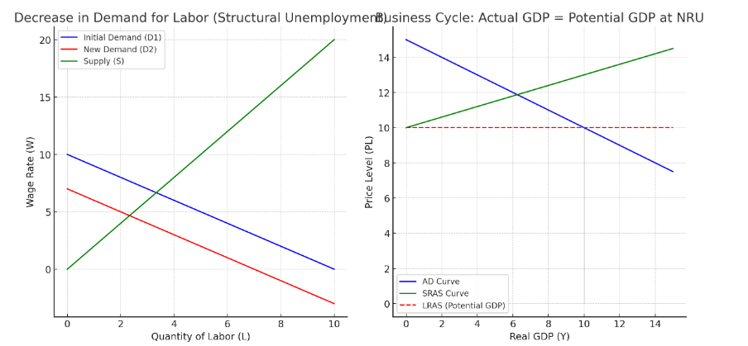
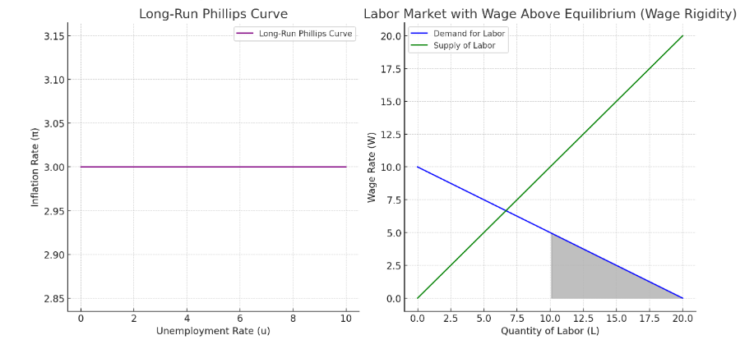
Here are the four requested diagrams:
- Labor Market Diagram Showing a Decrease in Demand for Labor (Structural Unemployment): This diagram illustrates a decrease in labor demand, shifting the demand curve left, leading to lower wages and employment, reflecting structural unemployment.
- Business Cycle Diagram (AD/AS) Showing Actual GDP Equal to Potential GDP at NRU: This diagram shows the intersection of the AD, SRAS, and LRAS curves at the potential GDP (LRAS), with no cyclical unemployment.
- Long-Run Phillips Curve Diagram: The long-run Phillips curve is vertical, indicating that inflation is stable at the natural rate of unemployment (NRU).
- Labor Market Diagram with Wage Above Equilibrium (Wage Rigidity): This diagram shows how setting wages above the equilibrium wage creates a labor surplus (unemployment) due to wage rigidity.

1. Labor Market Diagram Showing a Decrease in Demand for Labor (Structural Unemployment)
- Axes:
  - Vertical axis: Wage rate (W)
  - Horizontal axis: Quantity of labor (L)
- Steps to draw:
  - Draw an initial downward-sloping demand for labor curve (D1) and an upward-sloping supply of labor curve (S).
  - The equilibrium wage and employment are determined where the demand and supply curves intersect.
  - To show a decrease in demand for labor (structural unemployment), shift the demand curve to the left (D2).
  - The new equilibrium will be at a lower wage rate and lower level of employment (L2).
- Result: This shows how a decrease in labor demand leads to structural unemployment, where some workers may not find jobs due to skills mismatch or other factors, even at lower wage levels.

2. Business Cycle Diagram (AD/AS) Showing Actual GDP Equal to Potential GDP at NRU
- Axes:
  - Vertical axis: Price level (PL)
  - Horizontal axis: Real GDP (Y)
- Steps to draw:
  - Draw the Aggregate Demand (AD) curve, which slopes downward from left to right.
  - Draw the Short-run Aggregate Supply (SRAS) curve, which slopes upwards.
  - Draw the Long-run Aggregate Supply (LRAS) curve as a vertical line at the potential GDP level (Yp).
  - At the equilibrium point, where the AD curve intersects the SRAS curve, place this point at the same level as the LRAS curve to show that the actual GDP (Y) is equal to the potential GDP (Yp).
  - The Natural Rate of Unemployment (NRU) corresponds to this point, indicating that unemployment is at the natural rate with no cyclical unemployment.

3. Long-Run Phillips Curve Diagram
- Axes:
  - Vertical axis: Inflation rate (π)
  - Horizontal axis: Unemployment rate (u)
- Steps to draw:
  - Draw a vertical long-run Phillips curve (LRPC) at the Natural Rate of Unemployment (NRU), which is where inflation is stable and does not change due to fluctuations in unemployment.
  - Label the point on the curve at the NRU to show that long-term unemployment is constant, and inflation is not influenced by changes in unemployment.

4. Labor Market Diagram with Wage Above Equilibrium (Wage Rigidity)
- Axes:
  - Vertical axis: Wage rate (W)
  - Horizontal axis: Quantity of labor (L)
- Steps to draw:
  - Draw the initial demand for labor curve (D) and the supply of labor curve (S), showing the equilibrium wage (W0) and employment level (L0).
  - To show a wage above equilibrium (causing unemployment), draw a horizontal line above the equilibrium wage, labeled as the wage floor (W1).
  - This creates a situation where the wage is set above the equilibrium, causing the quantity of labor supplied (Ls) to be greater than the quantity of labor demanded (Ld), leading to unemployment.

b) Using real-world examples, evaluate the effectiveness of monetary policy in
reducing a large deflationary (recessionary) gap. [15]
Answers may include:
• Terminology: monetary policy, deflationary (recessionary) gap.
• Explanation: of how expansionary monetary policy can be used to counter a
deflationary gap using the various tools of monetary policy, such as open market
operations/quantitative easing, minimum reserve requirements and changes in the
central bank’s minimum lending rate.
• Diagram: AD/AS diagram to show AD shifting right with the deflationary gap being
closed/eliminated.
• Synthesis (evaluate): evaluation of the effectiveness of monetary policy in terms of
the limitations, eg limited scope for lowering interest rates when close to zero, low
consumer confidence, ineffective in relation to structural unemployment and the
possibility of greater inflation; and its strengths, eg short time lags, incremental,
flexible and easily reversible; comparison between the effectiveness of monetary
and fiscal policy when there is a large recessionary gap.
• Examples: real-world examples of monetary policy being used to counter a
deflationary gap.
Examiners should be aware that candidates may take a different approach which, if
appropriate, should be reward

Terminology:
- Monetary Policy: A set of actions taken by a central bank to influence the supply and cost of money in an economy to achieve specific goals, such as controlling inflation, stabilizing the currency, and fostering economic growth.
- Deflationary (Recessionary) Gap: A situation where the economy is producing below its potential output, causing unemployment to rise and economic output to fall. In this situation, aggregate demand is insufficient to match potential output, leading to deflationary pressures.
- Central Bank: The institution responsible for implementing monetary policy (e.g., Federal Reserve in the U.S., European Central Bank in the EU).
- Interest Rates: The cost of borrowing money, often used as a tool in monetary policy to influence spending and investment.
- Quantitative Easing (QE): A non-traditional monetary policy tool used by central banks when interest rates are near zero, involving large-scale purchases of financial assets to increase the money supply and lower long-term interest rates.

Explanation:
Monetary policy can be used to address a deflationary gap through various tools. When an economy faces a recession, central banks typically reduce interest rates to stimulate borrowing, investment, and consumer spending. If interest rates are already near zero, central banks may resort to unconventional methods such as quantitative easing to increase the money supply directly.
Expansionary Monetary Policy typically involves:
- Lowering Interest Rates: By reducing the cost of borrowing, both consumers and businesses are more likely to spend and invest, which boosts aggregate demand.
- Quantitative Easing (QE): This involves the central bank purchasing government bonds or other financial assets to increase the money supply and lower long-term interest rates, thus encouraging borrowing and spending.

Diagram:
In the AD-AS (Aggregate Demand - Aggregate Supply) model, a deflationary gap is depicted when the equilibrium output (Y1) is less than the potential output (Yp). The government or central bank will aim to shift the AD curve to the right by using expansionary monetary policy.
Diagram Explanation:
- AD Curve (Aggregate Demand) shifts rightward from AD1 to AD2 as a result of lower interest rates or quantitative easing, stimulating investment and consumption.
- The economy moves towards potential output, reducing the deflationary gap and mitigating the recession.

Synthesis (Evaluation):
While monetary policy can be effective in addressing a deflationary gap, its success depends on various factors:
- Liquidity Trap: In cases where interest rates are already close to zero, monetary policy may lose its effectiveness. A situation called a "liquidity trap" occurs when individuals and businesses prefer holding cash rather than borrowing or spending, regardless of low interest rates. This was evident during Japan’s “Lost Decade” in the 1990s, where despite low interest rates and substantial government bond purchases, deflation persisted.
- Time Lags: Monetary policy typically takes time to work through the economy. The effects of lower interest rates or QE may take several months or even years to fully impact aggregate demand and reduce unemployment.
- Effectiveness in Different Economic Environments: In economies with high levels of household debt or during times of global financial uncertainty, monetary policy may be less effective. For example, the global financial crisis of 2007-2008 saw central banks slashing interest rates and implementing QE. While these measures helped stabilize financial markets, they were not sufficient on their own to restore growth in many economies without complementary fiscal policies (e.g., government spending on infrastructure).
- Inflationary Pressures: While monetary policy aims to reduce a deflationary gap, overly aggressive monetary expansion can eventually lead to inflationary pressures. A delicate balance is required to ensure that inflation does not spiral out of control once the economy recovers. For example, after the COVID-19 pandemic, many countries saw inflationary pressures rise despite earlier monetary stimulus measures.
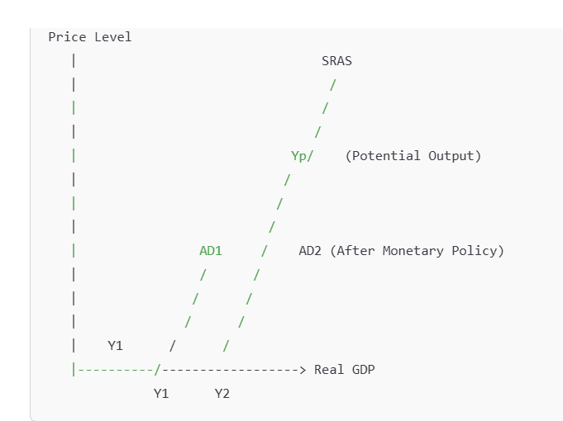

Explanation of the Graph:
- Initial Equilibrium: The economy starts at Y1, where aggregate demand (AD1) intersects the short-run aggregate supply (SRAS) curve, resulting in a deflationary gap because Y1 is below Yp (potential output).
- Expansionary Monetary Policy: The central bank lowers interest rates or uses quantitative easing, shifting the AD curve from AD1 to AD2.
- New Equilibrium: The new AD curve (AD2) intersects the SRAS curve at Y2, bringing the economy closer to its potential output Yp, reducing the deflationary gap.

3. (a) Explain how education programmes and health programmes can promote
economic development. [10]
Answers may include:
• Terminology: economic development.
• Explanation: of the benefits of education and health as merit goods with external
benefits for society at large which may impact positively on development, eg greater
labour productivity and output, lower unemployment, increased participation of
women in the labour force, attractiveness for FDI, control of contagious diseases,
links between health care and education
• Diagram: any relevant diagram, eg LRAS shifting to the right, a PPC diagram, a
positive externalities of consumption diagram, a Lorenz curve diagram or a poverty
cycle diagram.
A maximum of [6] should be awarded if only the importance of education programmes
or health programmes is explained.
Using real-world examples, discuss the view that the weak institutional framework
in many economically least developed countries (ELDCs) represents the most
significant barrier to economic growth. [15]
Answers may include:
• Terminology: economically least developed country, economic growth.
• Explanation: of the view in terms of how various aspects of the institutional
framework such as poorly-functioning legal system, ineffective/inequitable taxation
structure, underdeveloped banking system and lack of property rights may act as a
barrier to economic growth.
• Diagram: a diagram is not required for this question, but candidates may use a
LRAS/PPC diagram to illustrate economic growth in the long run and explain that
the weak institutional framework is preventing economic growth from happening.
• Synthesis (discuss): a challenge to the view in terms of the relative significance of
other economic and social/political barriers.
• Examples: real-world examples of countries facing a weak institutional framework
and/or other barriers to economic growth.
A maximum of [12] should be awarded if only weak institutional framework is
considered.
N.B. It should be noted that definitions, theory, and examples that have already been
given in part (a), and then referred to in part (b), should be rewarded.
Examiners should be aware that candidates may take a different approach which, if
appropriate, should be rewarded

2. (a) Explain two economic costs of high unemployment. [10]
(b) Using real-world examples, discuss the view that low unemployment can only be
achieved at the expense of higher inflation. [15]
3. (a) Explain how dependence on primary sector production may be a barrier to
economic growth. [10]
(b) Using real-world examples, evaluate the view that market-based policies may be
ineffective in promoting the economic development of the world’s poorest countries. [15
2. (a) Explain two economic costs of high unemployment. [10]
Answers may include:
• Terminology: unemployment.
• Explanation: of any two economic costs such as a loss of real output; higher
spending and lower tax revenues for the government with the possibility of a
larger budget deficit/ a smaller budget surplus; a more unequal distribution of
income; costs to the government of dealing with social problems caused by
unemployment; unemployed people may have difficulty finding work in the
future; specific problems related to the type of unemployment, eg structural or
cyclical.
• Diagram: any relevant diagram related to the particular cost being explained,
eg use of a PPC diagram or an AD/AS diagram.
A maximum of [6] may be awarded if only one cost is explained
(b) Using real-world examples, discuss the view that low unemployment can only be
achieved at the expense of higher inflation. [15]
Answers may include:
• Terminology: unemployment, inflation.
• Explanation: of the view in terms of higher AD as unemployment falls and thus
higher demand inflation and/or in terms of the short-run Phillips curve
relationship.
• Diagram: use of an AD/AS diagram, a short-run Phillips curve diagram and/or
a long-run Phillips curve diagram
• Synthesis (discuss): a challenge to the view in terms of the importance of the
type of unemployment being tackled, eg structural or cyclical, and the way in
which it is tackled, eg through the use of demand-side or supply-side policies;
Monetarist/new classical perspectives versus Keynesian perspectives; the
possibility of higher inflation and higher unemployment; the possibility of no
negative stable relationship between unemployment and inflation using the
long-run Phillips curve; consideration of the importance of technological
progress; consideration of the word “only”.
• Examples: real-world examples of situations where low unemployment may or
may not have coincided with higher inflation; use of empirical evidence.
N.B. It should be noted that definitions, theory and examples that have already
been given in part (a), and then referred to in part (b), should be rewarded.
Examiners should be aware that candidates may take a different approach which,
if appropriate, should be rewarded.

