CLASSWORK: The History of My Country
TOK Theme: Ethics and Historical Knowledge
Duration: 1 lesson (60 minutes)
Skill Focus: Critical Thinking | Reflection | Communication

- History Warm-up Activity: “Whose Story?”
Time: 30 minutes
Aim: To help students recognize how perspective shapes historical knowledge and to introduce the ethical dimension of history.
Step 1 – Visual Comparison
Visual 2 – Foreign/Objective Source
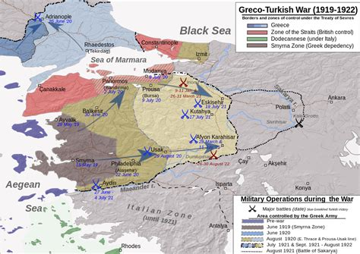
A military map from Western sources showing the Greco-Turkish War frontlines and territorial changes between 1919–1922.
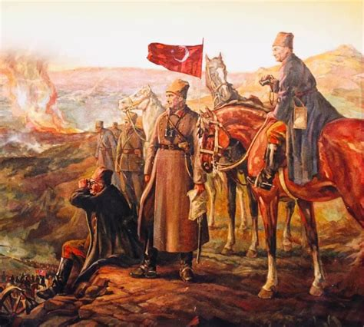
A classic Turkish depiction of the War of
Independence, highlighting national unity
and heroism.

Step 2 – Discussion Questions
- What differences do you notice between these two representations of the same event?
  - Consider what each image emphasizes or leaves out.
  - How do tone, symbols, and focus differ?
  - Which elements suggest a national, emotional, or factual approach?

- Can both representations be considered “true”? Why or why not?
  - Does perspective change what counts as historical truth?
  - How might the purpose or audience of each source affect how the story is told?

Knowledge Question:
“To what extent does the historian’s perspective shape the nature of historical knowledge?”

