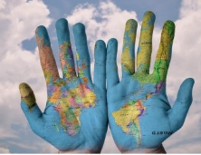
Language as a map

Draw the following…

Breakfast Cat Man


Woman Love Hope

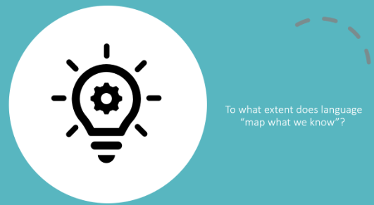
From knowledge as a map to language as a map…
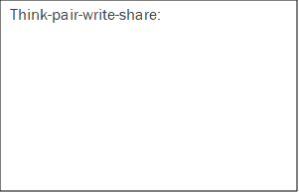

The language of an AOK:
Research and explore the nature, role, purpose of language within your allocated AOK.
Summarise your main findings here:

Reflection:
